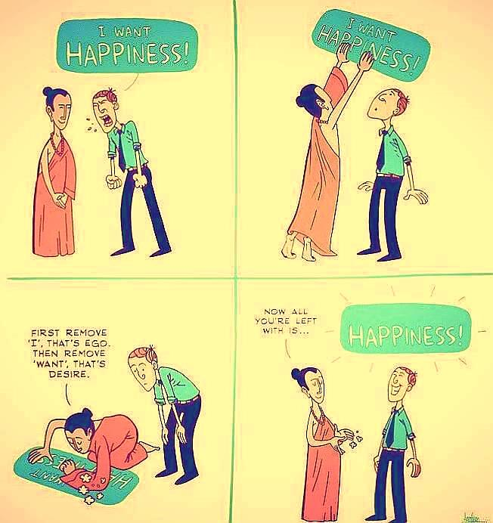Dwelling in the Space between Heaven and Earth

“Were not our hearts burning within us
while he was talking to us on the road,
and opening the scriptures to us?”

First Principle & Foundation of St. Ignatius of Loyola
- I am created to praise, reverence, and serve God our Lord, and by this means to save my soul.
- All other things … are created to help me attain this end
- All things that are a hindrance to this end should be avoided
- I need to become indifferent to all things save God alone…

Discernment of Spirits
(St. Ignatius of Loyola)

Good Spirits lead me in a good direction towards a good goal.

Bad Spirits make use of evil directions and even sometimes of what are at first good directions, to accomplish an evil end.

The action of good or bad spirits result in "movements” that occur within one's heart or spirit; we notice our spirit is lifted to God or is down, losing interest in God.

The words "good" and "bad/evil" as applied to "spirits" mean the source of the movement or feeling.

Good & bad spirits come from within ourselves, other people, or power more than human.

Ignatius likens the bad spirit to;

- a spoiled child. If a person is firm with such a child, the child gives up his petulant ways. But if a person shows indulgence or weakness in any way, the child is merciless in getting his own way by stomping his feet or by false displays of affection. So our tactics must include firmness in dealing with the evil spirit in our lives.

- a false lover. The false lover uses other people for his own selfish ends, uses people like objects or as playthings for entertainment. He usually suggests the so‑called intimacy of the relationship be kept secret because he is afraid that his duplicity will become known. So the evil spirit often acts in order to keep his temptations secret. Our tactics must be to bring into the light of day such suggestions and temptations to our confessor or spiritual companion.

- a shrewd army commander, who carefully maps out the tactics of attack at weak points of the defense. He knows that weakness is found in two ways:
- the weakness of fragility or unpreparedness,
- and the weakness of complacent strength which is pride.

- at first like an angel of light, to trick you.

Actions of the Good Spirit:

- One grows in awareness of patterns in life that lead away from a loving benevolent God

- One notices moments of freedom that come when I am not a slave to such patterns (sinfulness)

- One becomes less self-focused and oriented towards a greater trust in the benevolence of God in their lives
Signs of the Spirits in our Mature & Immature Selves

Immature aspects of a Christian:
Good spirit – uneasiness grows in me, or remorse sets in, so that I am moved to change.
Bad spirit – complacency or promise of pleasure, so there is no will to change direction of my life.

Mature aspects of a Christian:
Good spirit – strengthens, encourages, consoles, inspires, brings peace, conviction, continues my progress in the Lord.
Bad spirit – tries discouragement and deception to deter me from growing in the Christ‑life.
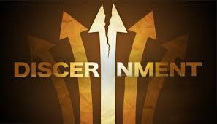
Direction in Life

Life in the world – Focus – Needs
Awareness and Attention to our Needs.
Luke 12:33-34
“Where your treasure is there will be your heart also”

Life in Christ – Focus – Gospel
Deepening of a life following the Gospel Values - Following Jesus.
Luke 9:23-25
“take up your cross daily and follow me.”

