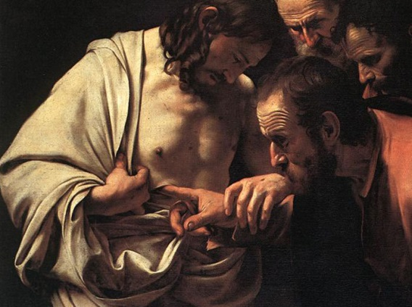

John 20:24-29

Jesus said to Thomas, “Put your finger here and see my hands. Reach out your hand and put it in my side.”

Matthew 20:20

Jesus came and said to them … “And remember, I am with you always, to the end of the age.”
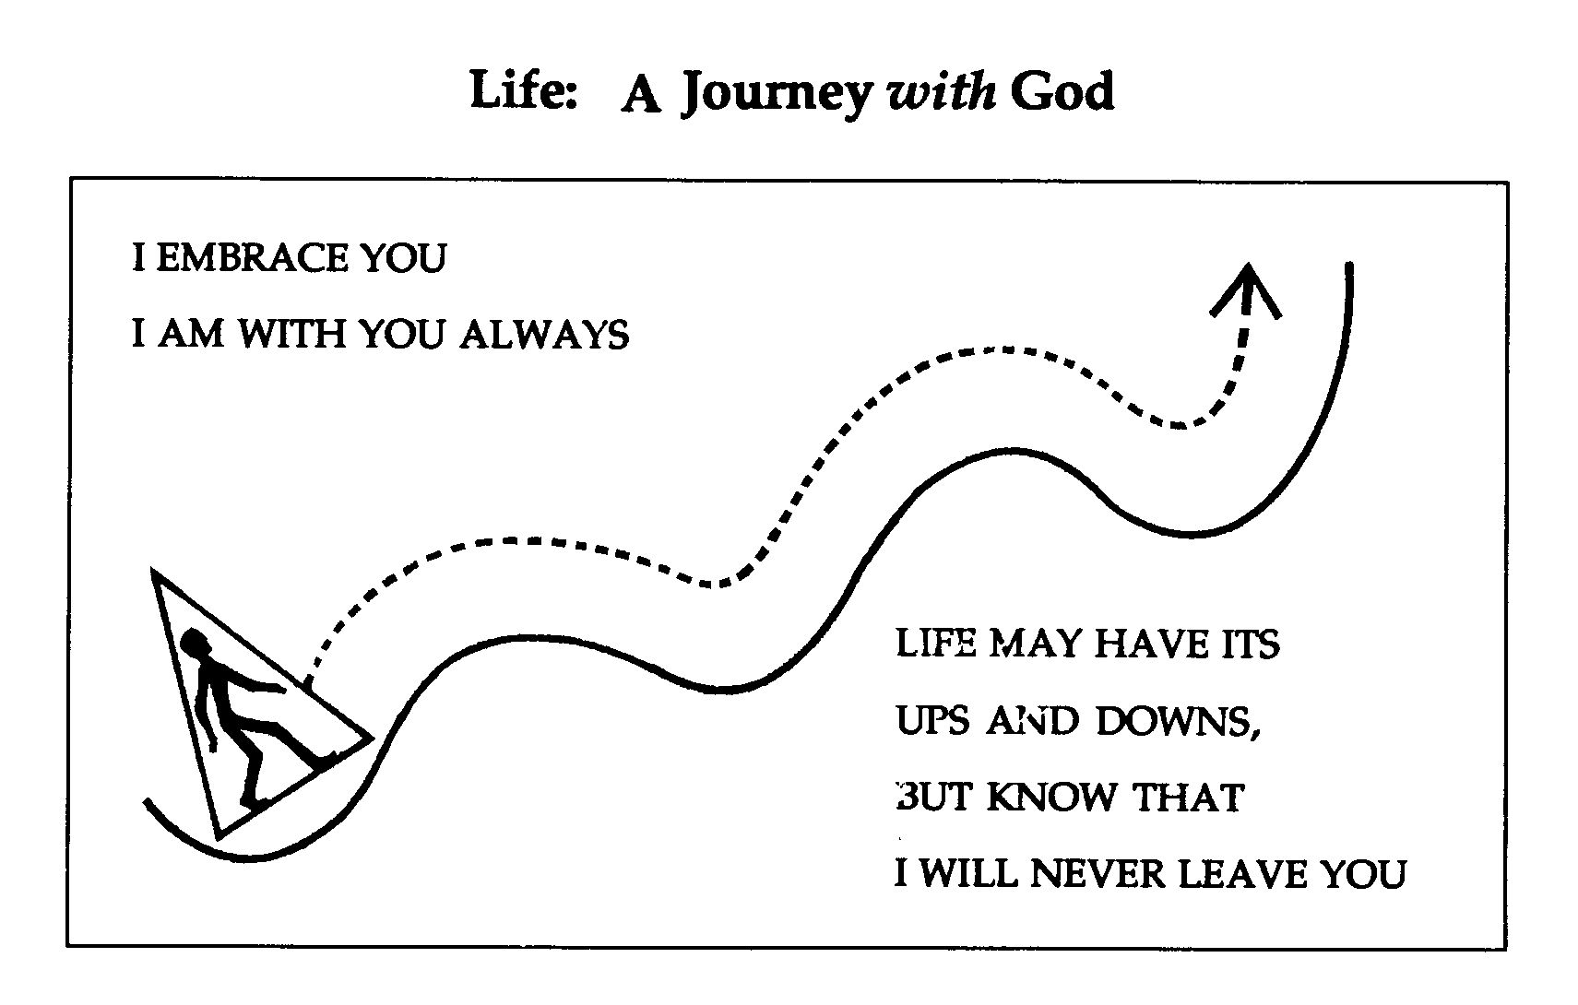
Luke 15:30-32

The father said to the elder son, ‘Son, you are always with me, and all that I have is yours. ”

Jesus Came Near

and Went with Them

“While they were talking, Jesus himself came near
and went with them, and he said to them,
“What are you discussing while you walk along?”
Exodus 13:21
The Lord went in front of them in a pillar of cloud by day, to lead them along the way, and in a pillar of fire by night, to give them light, so that they might travel by day and by night.

John 8
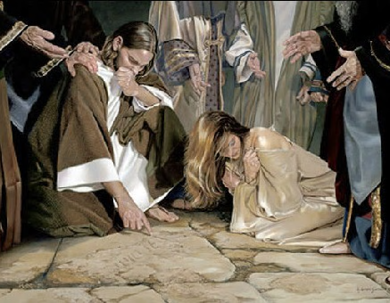
… he bent down and wrote on the ground. …. and Jesus was left alone with the woman standing before him. Jesus straightened up and said to her, “Woman, where are they? Has no one condemned you?” She said, “No one, sir.” And Jesus said, “Neither do I condemn you.”

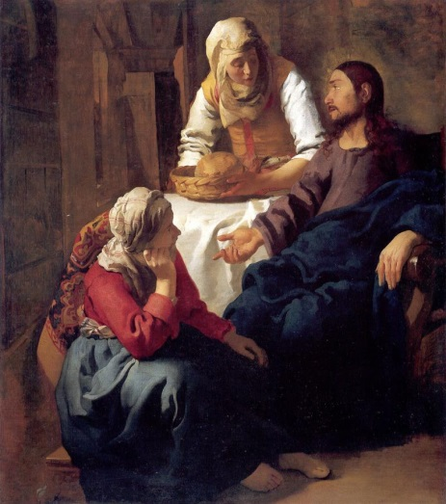

Luke 15:1-32

… while he was still far off, his father saw him and was filled with compassion; he ran and put his arms around him and kissed him.

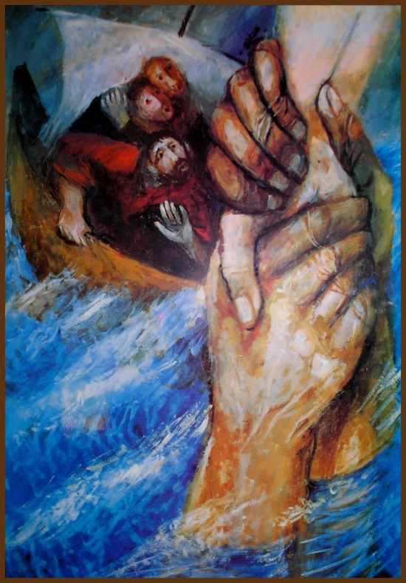

Matthew 15:22-33

But when he noticed the strong wind, he became frightened, and beginning to sink, he cried out, “Lord, save me!” Jesus immediately reached out his hand and caught him,

Luke 10:38-42

“Martha, Martha, you are worried and distracted by many things; there is need of only one thing. Mary has chosen the better part, which will not be taken away from her.”
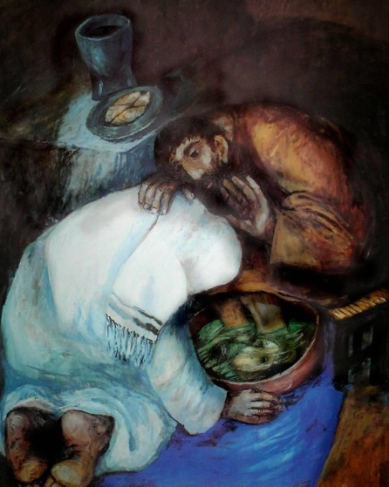

John 13

Jesus got up from the table, took off his outer robe, and tied a towel around himself. He poured water into a basin and began to wash the disciples’ feet and to wipe them with the towel that was tied around him. He came to Simon Peter, who said to him, “Lord, are you going to wash my feet?” Jesus answered, “You do not know now what I am doing, but later you will understand.” Peter said to him, “You will never wash my feet.” Jesus answered, “Unless I wash you, you have no share with me.”
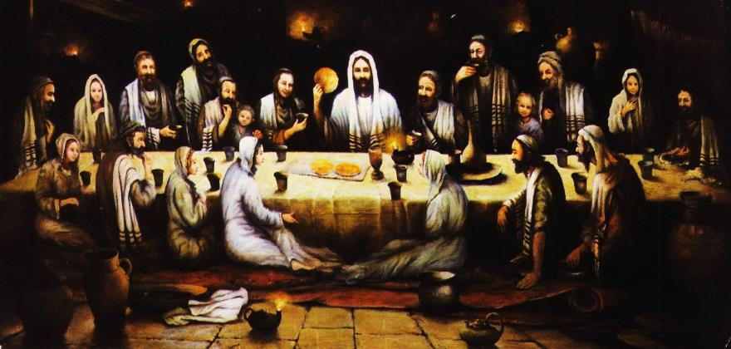
I give you a new commandment, that you love one another just as I have loved you. By this everyone will know that you are my disciples

